Project #4

Blake Green, Brock Hoover, Levi Woockman

April, 20, 2026

Table of Contents
Introduction: 2
National Risk Index Definition: 3
Proposed Risk Definition: 3
Methods 3
Results using National Risk Index data: 4
Results using Proposed Risk Index data: 8
Proposed Risks by County for Iowa and Wisconsin 8
Proposed Risk Maps by Tract for Iowa and Wisconsin 10
Limitations of Our Proposed Risk Definition: 11
References: 11

Introduction:
In this project, we were hired by the firm Risk Averse, LLC to review where bias may exist in the National Risk Index scoring methodology by performing what is referred to as a sensitivity analysis. Our goal of this project was to compare the current risk levels as defined by the NRI methodology with our own methodology and to observe how the outputs change as a result. For this project, we chose Iowa and Wisconsin as our two states due to them having similar risks and being close to our project team’s home state of Nebraska.

National Risk Index Definition:
The National Risk Index risk definition is defined as expected annual loss times social vulnerability divided by community resilience. According to the December 2025 v1.20 national risk index dataset FAQ sheet, the national risk index data is intended for planners and emergency managers at the local, regional, state, and federal levels. The national risk index dataset provides three different types of results: Values, which represent the communities average economic loss per year from hazards, Scores, which represent the communities percentile compared to other communities, and the rating, which qualitatively describes the community in comparison to other communities at the same level.

Proposed Risk Definition:
For our group, we have a custom risk definition which has frequency multiplied by agricultural exposure, frequency multiplied by population exposure, and frequency multiplied by agricultural loss rate. Since Iowa and Wisconsin are states that rely heavily on their agricultural industries, any negative impact on the industry due to weather puts areas in the state at high risk, which is why we chose this definition to evaluate risk of tracts in Iowa and Wisconsin. The exact variables chosen for our proposed risk definition can be seen in Figure 1.
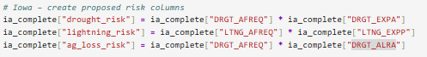
Figure 1, Proposed Risk definition column

Methods

The first step was to download all relevant data files. Census tract level data for Iowa and Wisconsin were downloaded from the FEMA National Risk Index and loaded into Python using pandas. The NRI file was used to identify relevant variables including expected annual loss, social vulnerability, community resilience, and the specific hazard exposures. Any missing or unordinary values dropped so that these did not affect the results.
The Social Vulnerability Index dataset from the CDC/ASTDR was downloaded separately and then merged to the NRI dataset. This was done using the FIPS column as a shared column. This allowed us to have one complete dataset so that coding moving forward would be simplified, and analysis was easier as well.
For the NRI risk scoring, census tract risk scores and ratings were pulled from the NRI risk index percentile field and mapped using GeoPandas. From this, we were able to produce multiple maps displaying risk information based on NRI scoring or hazard analysis. For our proposed risk definition, a custom score was calculated using the proposed risk definition from Figure 1.
The results were then aggregated to find the top 10 highest risk counties in each state. GeoPandas was used with the census tract shapefiles to generate choropleth maps visualizing the NRI risk scores and our proposed risk scores for Iowa and Wisconsin.

Results using National Risk Index data:
Using the national risk index data, our project team made several figures applicable to the project. In Figure 2 and Figure 3, you can see the results of the NRI risk score by census tract in Iowa and Wisconsin respectively.
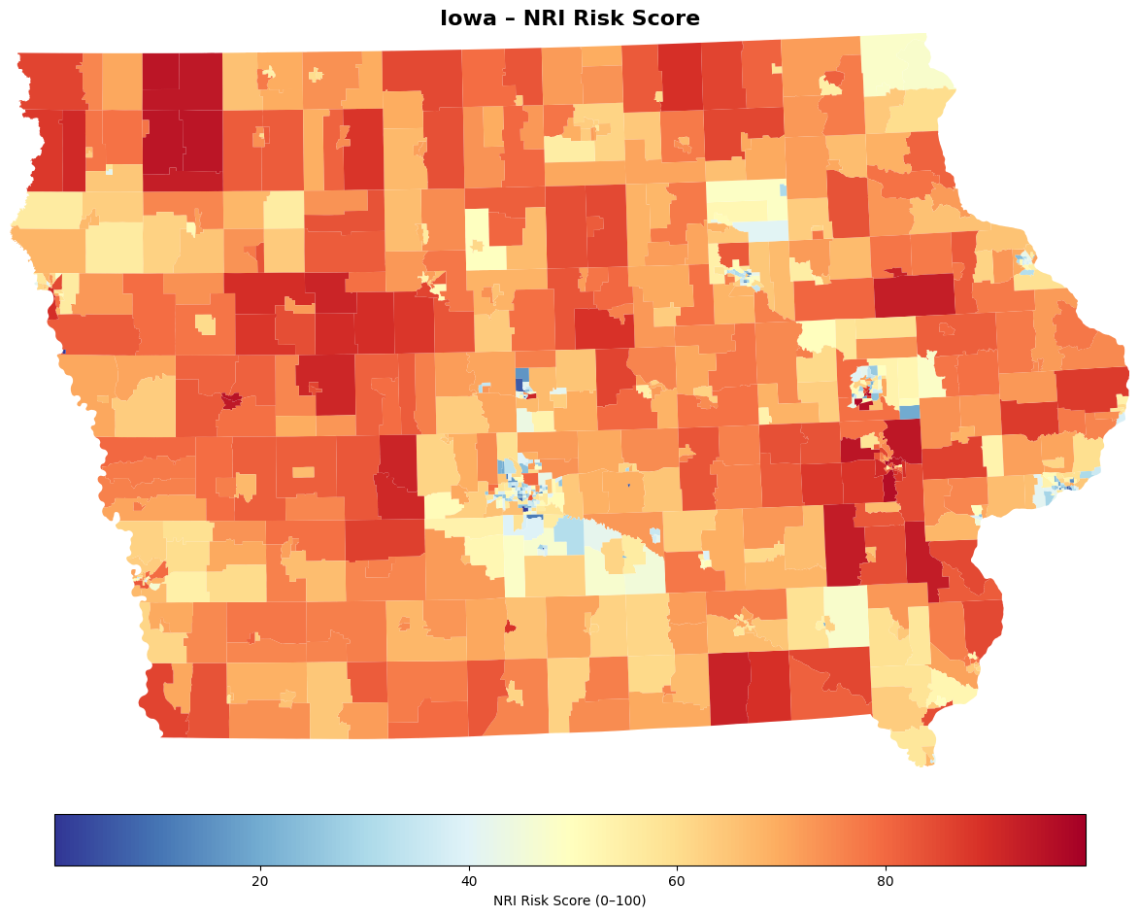
Figure 2, Iowa NRI Risk Score
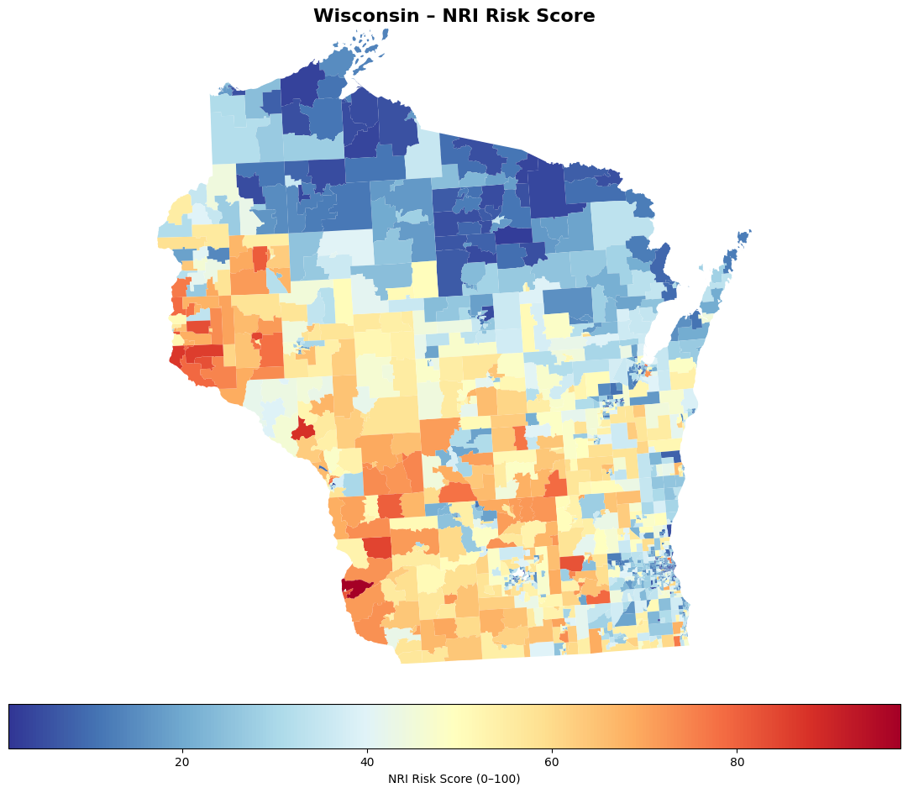
Figure 3, Wisconsin NRI Risk Score
From these maps, it appears that the Urban communities have lower risk scores, while the rural communities have higher risk scores. Iowa in particular has very high-risk scores in general across the entire state. While the NRI data is helpful to give a general baseline for the risk of an area, it doesn’t differentiate by specific risk factors, so mitigation strategies in one area are not going to be as helpful as others. Risk is a hard thing to define in one factor, which is why our team’s risk factor isn’t as general, and should only be used for certain purposes. Maps of the ratings were also generated by our project team, but for technical purposes our project team believes the risk score maps are better suited. The rating maps can be seen in Figure 4 and Figure 5
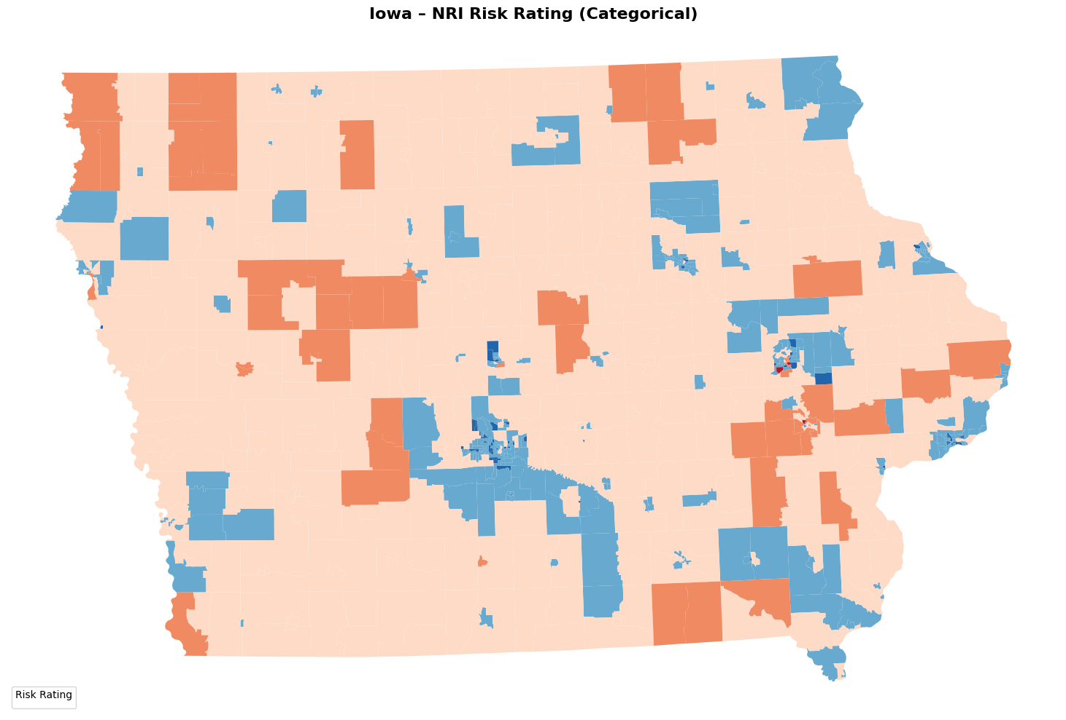
Figure 4, Iowa Categorical NRI Risk Rating by Tract
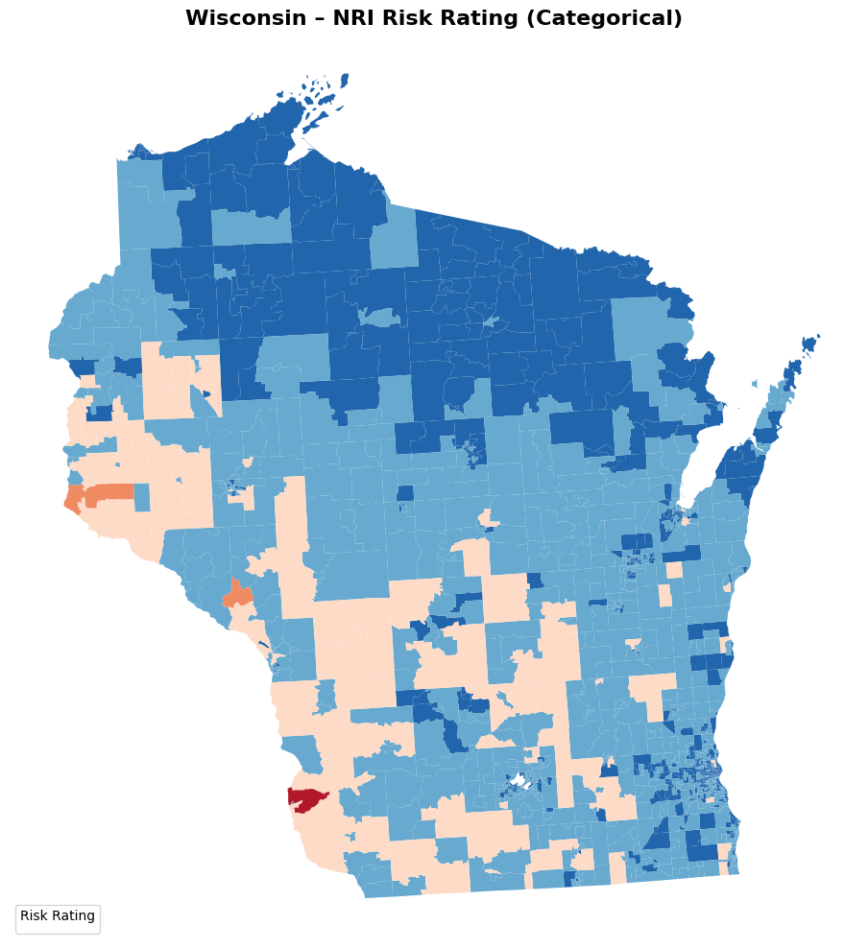
Figure 5, Wisconsin NRI Risk Rating by Tract

Results using Proposed Risk Index data:

Proposed Risks by County for Iowa and Wisconsin
For our project team to identify the counties with the highest proposed risk, we looked at the proposed drought risk by county for Iowa and the proposed lightning risk by county for Wisconsin, and identified which counties would be at the highest risk for certain events. The Iowa plot is in Figure 6, and the Wisconsin plot is in Figure 7.
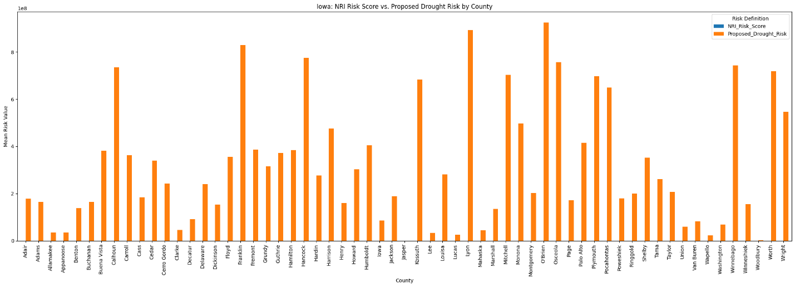
Figure 6, Iowa Proposed Drought Risk by County
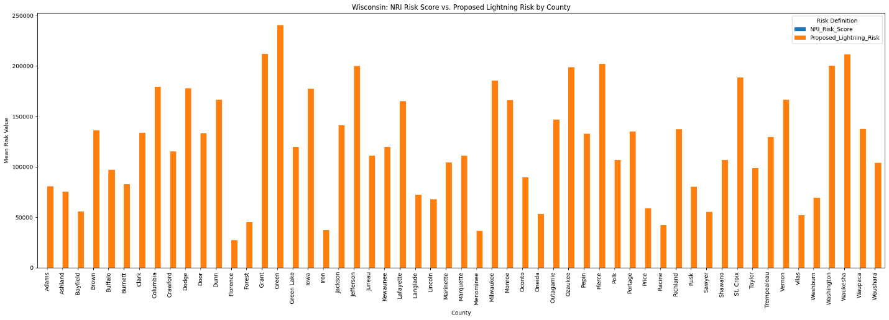
Figure 7, Wisconsin Proposed Lightning Risk by County
For client accessibility and as an addition to the charts, we also created tables that show the top 10 counties for each state by our proposed risk definitions which can be seen in Table 1 and Table 2.

Table 1, Iowa: Top 10 Counties by Proposed Drought Risk
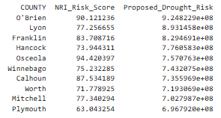
Table 2, Wisconsin: Top 10 Counties by Proposed Lightning Risk
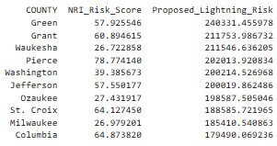

For Iowa, the county with the highest drought risk was O’Brien County, which appears to have struggled with droughts to the point where FEMA designated it as a natural disaster area due to drought events in 2022.

For Wisconsin, the county with the highest lightning risk was Green County, which has struggled with hail in the last few days as mentioned in a 15 WMTV article by Calahan Steed. Green County is lower on the NRI index compared to other counties in the state.

Proposed Risk Maps by Tract for Iowa and Wisconsin
Our project team used GeoPandas to create a proposed drought risk map for Iowa and a proposed lightning risk map for Wisconsin. The Iowa map can be seen in Figure 8, and the Wisconsin map can be seen in Figure 9.
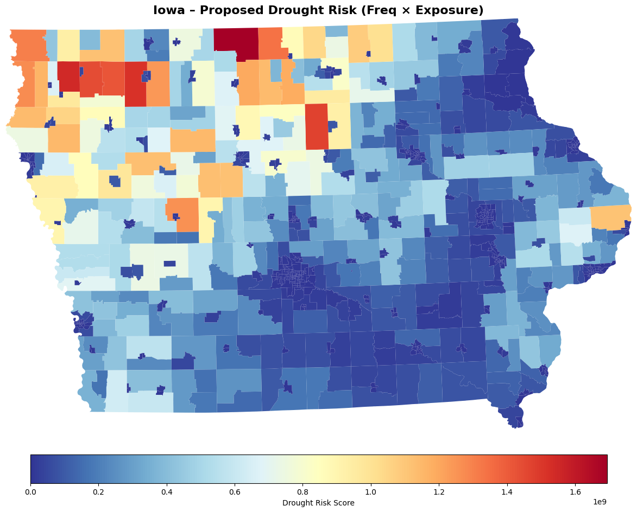
Figure 8, Iowa Proposed Drought Risk

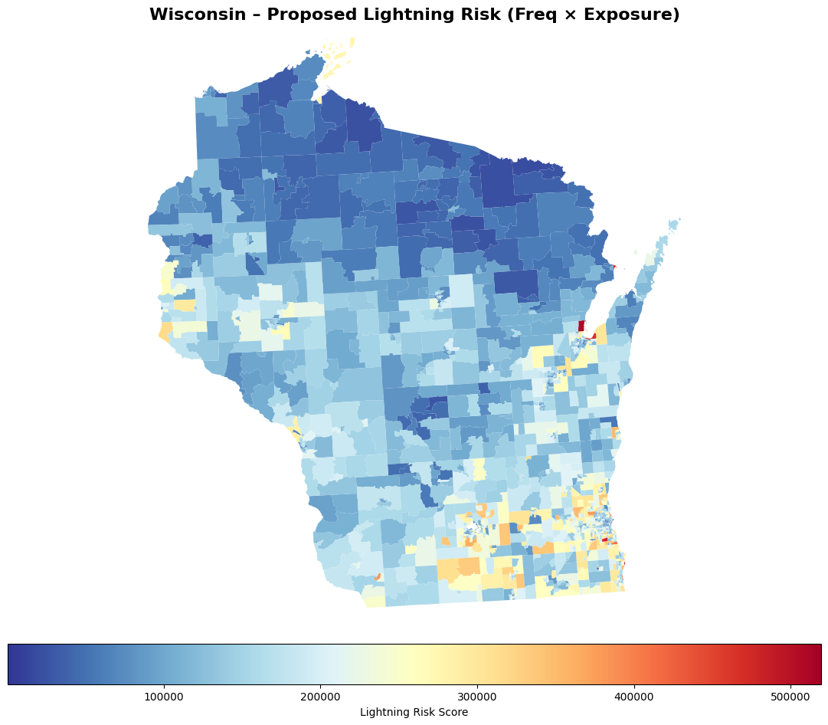
Figure 9, Wisconsin Proposed Lightning Risk
These maps allow for an easy visualization of what regions of a state are at the highest risks for these events. Northwest Iowa has higher drought risks, and Southeastern Wisconsin generally has higher risks for lightning. This information can be used by FEMA for which regions to prioritize monitoring potential aid needs.

Limitations of Our Proposed Risk Definition:
For our project teams proposed risk definition, it only looks at certain events and does not consider the totality of risk factors for each county. Our project team believes that our risk definition should be primarily used as a tool for monitoring from FEMA, and not as a system to immediately distribute funds to states. Because of the use of the exposure factor, our proposed risk definition might bias against smaller tract areas and smaller counties, so this should be kept in mind when FEMA is determining risk and how to allocate funds to areas.

References:
Farm Service Agency. (2022, July 15). USDA designates Cherokee, O’Brien counties as primary natural disaster areas. U.S. Department of Agriculture. https://www.fsa.usda.gov/news-events/news/07-15-2022/usda-designates-cherokee-obrien-counties-primary-natural-disaster-areas

Federal Emergency Management Agency. (2025, December). National risk index data: Frequently asked questions. U.S. Department of Homeland Security. https://www.fema.gov/sites/default/files/documents/fema_national-risk-index_faq-page-documentation.pdf

Federal Emergency Management Agency. (2026, April 8). Resilience analysis and planning tool (RAPT). U.S. Department of Homeland Security. https://www.fema.gov/emergency-managers/practitioners/resilience-analysis-and-planning-tool

WMTV 15 News. (2026, April 18). Tornadoes, flooding, hail create havoc across southern Wisconsin. https://www.wmtv15news.com/2026/04/18/tornadoes-flooding-hail-create-havoc-across-southern-wisconsin/

